Title: **Leveraging Digital Technologies for Sustainable Economic Growth**

Sponsored by: UNITAR Hackathons

**Project Title: Exploring the Impact of Emerging Technologies on Sustainable Economic Growth**

Project Description:

This project aims to elucidate the connection between Digital Technologies and Sustainable Economic Growth. It will demonstrate how digital technologies can revolutionize and empower economic performance for sustainability, creating a platform for digital inclusion and skill development to achieve sustainable economic growth.

Executive Summary:

This project seeks to highlight the relationship between Digital Technologies and Sustainable Economic Growth. It will illustrate how these elements are interconnected and how digital technologies can drive economic performance towards sustainability. By creating a platform for digital inclusion and skill development, this project aims to facilitate sustainable economic growth.

Background and Objective:

Digital Technologies have brought about significant social changes through their association with the economy, such as the Industrial Revolution. They offer powerful tools and innovative solutions to address environmental challenges and promote economic growth. For example, technologies like IBM Cloud, Artificial Intelligence (AI), Blockchain, The Internet of Things (IoT), and Quantum computing are instrumental in keeping companies ahead of the technology curve. AI, for instance, plays a vital role in healthcare by enabling early disease detection and personalized treatment options. In finance, AI aids in detecting fraudulent activities and providing customized investment advice.

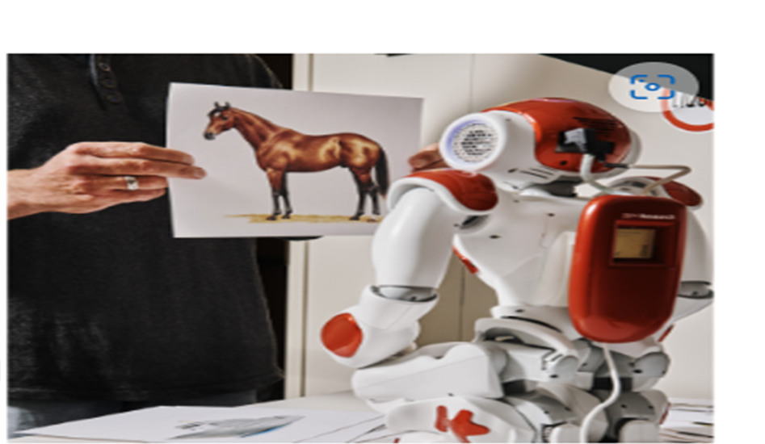

Motivation:

Digital Technologies are reshaping various sectors of life, benefiting more people and providing opportunities for the most vulnerable. To leverage this potential and ensure inclusivity and sustainability, intentional efforts are needed to steer technology development and national digital transformation.

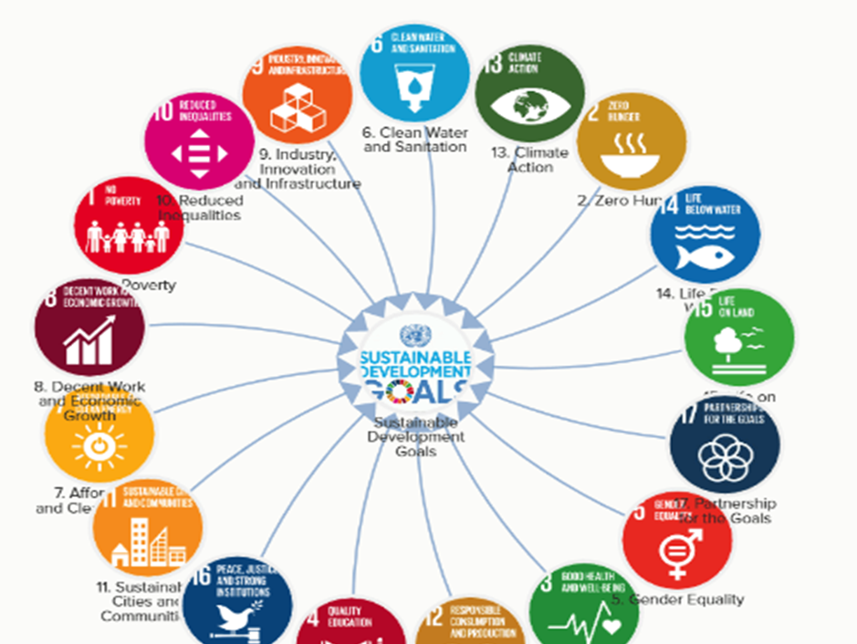

Success Story:

Efficient digital technologies reduce the need for physical space, minimizing land and resource usage and alleviating pressure on natural resources. Technologies also help reduce consumption and waste, increase efficiency, and mitigate environmental impacts. For example, renewable energy technologies like Solar Panels and wind turbines reduce reliance on fossil fuels, a major contributor to climate change. Additionally, digital technologies facilitate efficient dissemination of business-related information, enhancing economic activities.

Solution:

Digital Technologies, as drivers of innovation, are crucial for sustainable economic growth. Focus on AI and data science can increase the availability of high-quality, timely, and reliable performance data disaggregated by various characteristics. This is essential given the abundance of data available and the potential of AI to perform complex tasks. Qualitative and quantitative data can help monitor progress towards sustainable economic growth, although more efforts are needed in this regard.

References:

IBM SkillsBuild Learning: [killsBuild (ibm.com)](https://skills.yourlearning.ibm.com/?strategy=ibmid&lang=en&source=login&learning_path=https:%2F%2Fskills.yourlearning.ibm.com%2Factivity%2FPLAN-6B23595093AD)

Three Ways Digital Transformation Accelerates Sustainable Development: <https://www.undp.org/blog/three-ways-digital-transformation-accelerates-sustainable-and-inclusive-development>

<https://www.youtube.com/feed/history?app=desktop>

The digital frontiersin.org

<https://www.frontiersin.org/articles/10.3389/fenvs.2023.1124680/full>

<https://youtu.be/dFEdY24y1Kk?si=P_poCv7YKstjzCOg>

Relationship between Digital Technologies and Sustainable Development (Economic) Growth Diagram: <https://www.mdpi.com/1660-4601/19/19/12273>

Success impact of Technology on the enviroment

Sciencedirect.com <https://www.sciencedirect.com/science/article/pii/S0959652623042373>

Article on Digital Economy as the Main Driver of Economic Growth: <https://youtu.be/uswU1s3M2VE?si=1LwpuMGewODXN6lj>

<https://youtu.be/7dzFbP2AgFo?si=4vsJvTV618vZLMg5>